\documentclass[a4paper,12pt]{article}

\usepackage[margin=1in]{geometry}

\usepackage{array}

\usepackage{longtable}

\begin{document}

\begin{center}

\textbf{K. J. Somaiya College of Engineering, Mumbai -77} \\

(A Constituent College of Somaiya Vidyavihar University) \\

\textbf{Department of Information Technology}

\end{center}

\vspace{0.5cm}

\begin{table}[h!]

\renewcommand{\arraystretch}{1.5}

\setlength{\tabcolsep}{8pt}

\centering

\begin{tabular}{|c|c|}

\hline

\textbf{Course Code} & \textbf{Course Title} \\ \hline

116U04C601 & Object Oriented Software Engineering \\ \hline

\end{tabular}

\vspace{0.5cm}

\begin{tabular}{|c|c|c|c|c|}

\hline

\textbf{TH} & \textbf{P} & \textbf{TUT} & \textbf{Total} \\ \hline

3 & -- & -- & 3 \\ \hline

\textbf{Teaching Scheme(Hrs.)} & \multicolumn{3}{c|}{\textbf{Credits Assigned}} \\ \hline

3 & -- & -- & 3 \\ \hline

\end{tabular}

\vspace{0.5cm}

\begin{tabular}{|c|c|c|c|c|c|c|c|}

\hline

\multicolumn{8}{|c|}{\textbf{Examination Scheme}} \\ \hline

\textbf{CA} & \multicolumn{2}{c|}{\textbf{ESE}} & \textbf{TW} & \textbf{O} & \textbf{P} & \textbf{P\&O} & \textbf{Total} \\ \hline

ISE & IA & ESE & -- & -- & -- & -- & \textbf{100} \\ \hline

30 & 20 & 50 & -- & -- & -- & -- & \\ \hline

\end{tabular}

\end{table}

\vspace{1cm}

\noindent \textbf{Course prerequisites:} Object Oriented Concepts

\vspace{0.5cm}

\noindent \textbf{Course Objectives:}

\begin{itemize}

\item This course imparts the knowledge about object-oriented approach of software development phases, including requirement analysis, modeling, design, and testing.

\item The course content emphasizes the significance of project estimation and planning.

\item The course encourages the use of design and modeling principles for software development.

\end{itemize}

\vspace{0.5cm}

\noindent \textbf{Course Outcomes:} \\

At the end of the successful completion of the course, the student will be able to:

\begin{itemize}

\item CO1: Comprehend process models.

\item CO2: Describe software planning and management.

\item CO3: Demonstrate requirements, modeling, and design of a system.

\item CO4: Demonstrate test case design.

\end{itemize}

\end{document}

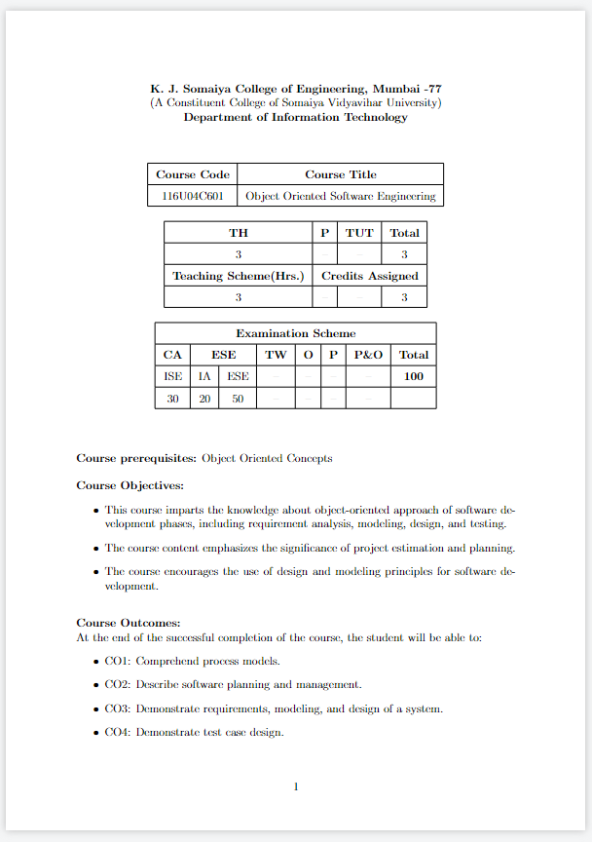

\documentclass[a4paper,12pt]{article}

\usepackage[margin=1in]{geometry}

\usepackage{array}

\usepackage{longtable}

\begin{document}

\renewcommand{\arraystretch}{1.5}

\setlength{\tabcolsep}{5pt}

\begin{longtable}{|c|c|p{10cm}|c|c|}

\hline

\textbf{Module No.} & \textbf{Unit No.} & \textbf{Details} & \textbf{Hrs.} & \textbf{CO} \\ \hline

\endfirsthead

\hline

\textbf{Module No.} & \textbf{Unit No.} & \textbf{Details} & \textbf{Hrs.} & \textbf{CO} \\ \hline

\endhead

1 & 1.1 & Software Engineering, Layered Technology, Process Framework, Capability Maturity Model (CMMI) & 7 & CO1 \\ \hline

& 1.2 & Prescriptive Models, Waterfall Model, Incremental, RAD, Evolutionary Process Models, Prototyping, Spiral, Test Driven Development & & \\ \hline

& 1.3 & Agile Process, Scrum - Industry Perspective, \textbf{DevOps Development Practice} & & \\ \hline

2 & 2.1 & Software Estimation, LOC, FP, Basic COCOMO Model, Software Project Management Plan (SPMP) & 10 & CO2 \\ \hline

& 2.2 & Scheduling, Work Breakdown Structure, Gantt Chart, Tracking the Schedule & & \\ \hline

& 2.3 & Risk Identification, Risk Assessment, Risk Projection, RMMM Plan & & \\ \hline

& 2.4 & Software Configuration Items, SCM Process, Identification, Version Control, Change Control, Configuration Audit, Status Reporting & & \\ \hline

3 & 3.1 & Requirements Engineering Tasks, OO Requirements & 4 & CO3 \\ \hline

& 3.2 & Functional and Non-Functional Requirements & & \\ \hline

& 3.3 & Eliciting Requirements & & \\ \hline

& 3.4 & Software Requirements Specification (SRS) & & \\ \hline

4 & 4.1 & Importance of Modeling, Conceptual Model of the UML & 20 & CO3 \\ \hline

& 4.2 & Use Case Diagram, Activity Diagram, State Diagram, Interaction Diagrams, Class Diagram, Deployment Diagram, Component Diagram, Data Flow Diagram (DFD) & & \\ \hline

& 4.3 & Design Concepts, Analysis Model, Design Model, Design Principles and Concepts, Software Design Document (SDD) & & \\ \hline

& 4.4 & Software Design, Data Design, EER, Class, Architecture Styles, Data Centered, \textbf{MVC}, Client Server, User Interface Design Rules and Process, Component Level Design, Component, Views, Effective Modular Design, Cohesion and Coupling, Design Patterns, Singleton, Observer, Adapter, Façade & & \\ \hline

5 & 5.1 & OO Testing Methods, OO Testing Strategies, Test Case Design, Class Level and Interclass Level, Software Test Document (STD) & 4 & CO4 \\ \hline

& 5.2 & Software Maintenance, Types, Reverse Engineering, Re-engineering & & \\ \hline

& & \textbf{Total} & \textbf{45} & \\ \hline

\end{longtable}

\end{document}

